[Provider Name: Challenge Title]
Challenge Brief

Contact name |  | Response deadline
Enter Full Name Here |  | October 20, 2017
Phone number |  | Challenge Brief reference #
Enter Phone# Here |  | Enter A Unique Number
E-mail |  | Maximum procurement budget
Enter Email Address Here |  | $
 |  | Note: this does not obligate provider to procure any solution
Enter Full Names And Roles
Project Team
The Challenge
Maximum of 1200 characters
A good challenge statement is specific enough to offer a focused starting point yet broad enough to consider many ways to tackle it.

Too broad: “How to reduce falls in our senior care homes.”

Too specific: “We will reduce falls by 25% in the next year by creatively using wearable technology to monitor our residents during high-risk activities.”

More balanced: "How might we improve the quality of life of our residents by reducing falls in our senior care homes by 25% in the next year, by focusing on the top 3 causes (getting out of bed, entering and exiting the shower, sitting and standing)?"

Remember to address the following questions:
- How is this challenge important to the organization to deliver better care?
- How is this a challenge also faced by other organizations?
- What are some ways that you have tried to solve this challenge in the past?
- Why do current solutions in the market fall short of solving this challenge?

Desired Outcomes
Maximum of 3 outcomes based specifications (OBS)
OBS specify the ultimate outcomes and performance desired by the end user, allowing for flexibility in determining how a specific need can be met. Here are some examples:

OBS #1: HospitalX is interested in reducing appointment no-shows from the current rate of 17% to less than 10% as measure over a 3-month period.

OBS #2: Increase patient satisfaction compared to the status quo. A baseline metric will be established during testing, and a minimum of 20% increase in patient satisfaction over the status quo is expected from the solution during a 3-month testing period.

OBS #3: Decrease clinical administrative load as measure by time saved and/or increased efficiency by a minimum of 20% over a 3-month test period.

Evaluation Criteria
Criteria to be used for vendor selection (NOT to evaluate solutions).

IMPORTANT: Below are evaluation categories for provider’s use. Please modify according to your needs by adding any sub-criteria and weights if necessary.

Company
Has the company demonstrated the competency to act as partner? Do they have an innovative vision? Do they have a strong leadership team? Do they have strong references?

Proposed approach
Is the proposed approach to the challenge innovative? Do you agree that it can solve the challenge proposed? Will it have a significant impact on the end user (staff, patients, etc)?

Ability to execute
Has the company demonstrated the ability to deliver a solution to other complex challenges? What has been the outcomes of solutions they have implemented?

Ability to produce validation data
Has the company demonstrated their ability and expertise to produce validation data? Have they shared an example of data they have produced for any of their products or prototypes? Is the quality of that data sufficient enough to make a procurement decision?

Experience of project team
Does the team have experience working on innovative solutions? Did the company propose the right type of project team to take on this engagement?

Key Dates
The following is a summary of key dates in the RFP process. Program sponsor (MaRS) and provider may change any of the dates below, in its sole discretion and without liability, cost, or penalty.

Key Dates | Milestones | Duration
Sept 28, 2017 | Program launch, providers invited to download and complete a Challenge Brief | 2 weeks
Oct 16 - 20 | All challenges posted online, vendors begin to respond with Innovator Briefs | 1 week
Oct 23 - 27 | Vendors have all submitted Innovator Briefs. Providers shortlist vendor selection. | 1 week
Nov 6 | Dialog day. Each provider will hear their selected vendor pitches. Final vendor selection completed. | 1 day
Nov 7 - 10 | Teams prepare and submit co-design grant application. | 1 week
Nov 13 - 17 | External judging panel reviews grant applications. Meets on 17th to make final decision. Co-Design grant winners announced. | 1 week
Nov 20 | Co-Design Workshop #1: Discovery. Teams sign collaboration agreements. | 1/2 to 1 day
Nov 20 - Dec 15 | Teams work on discovery phase. | 4 weeks
Jan 15, 2018 | Co-Design Workshop #2: Ideation & Concept testing | 1/2 to 1 day
Jan 15 - Mar 3 | Teams work on ideation and concept testing phase. | 8 weeks
Mar 5 - 8 | Design review sessions. 1 - 2 hour sessions with each team to review learnings from discovery and concept testing results. | 1 week
Mar 9 | Co-Design Workshop #3: MVP prototyping and evaluation framework. | 1/2 - 1 day
Mar 9 - Jun 15 | Teams work on MVP development and evaluation phase. | 14 weeks
Jun 18 - Jul 5 | Teams make procurement decision and formalize agreements. | 3 weeks
Jul 9 - 13 | External judging panel conducts site visits. | 1 week
Jul 20 | Final solutions day. Judges award up to $50k for procurement. | 1 day

Terms and Conditions
- The “Innovation Partnership: Procurement by Co-Design” program may or may not lead to a procurement. There is no requirement for procurement at the end of the program, and procurement is at the discretion of the Provider. There are a number of potential outcomes from participation in this program (see figure below).
- This Design Challenge document is issued to invite vendors who are able to develop solutions within the program timelines or have existing solutions that require refinement or validation, to respond and partner with the Provider to solve the proposed challenge.
- The process will be in four phases:
  - Phase 1: Challenge Brief
    - Proponents prepare a submission in response to OBS
    - Providers evaluate submissions based on evaluation criteria published in Challenge Brief, and generate a short list of qualified proponents
  - Phase 2: Dialogue Day
    - Short listed proponents are invited to present on submissions
    - Providers evaluate presentation/discussion based on published criteria (to be made available to short listed proponents) and a proponent is selected. There are now two possible outcomes:
      - Proponent may find an ideal solution and decide to pursue an RFP/S or non-competitive procurement strategy
      - Proponent may form a team to pursue co-design
  - Phase 3: Co-Design
    - Selected proponent and provider form a team to co-design a solution and evaluate a minimum viable product, and decide whether to apply for the co-design grant. There are now three possible outcomes:
      - Co-design moves forward with grant funding
      - Co-design moves forward without grant funding
      - Co-design does not move forward
  - Phase 4: Procurement
    - Providers evaluate success of the minimum viable product based on published desired outcomes
    - Providers determine whether to move forward with a procurement, and whether to request the additional grant from IPPCD. There are now three possible outcomes:
      - Procurement moves forward with grant funding
      - Procurement moves forward without grant funding
      - Procurement does not move forward

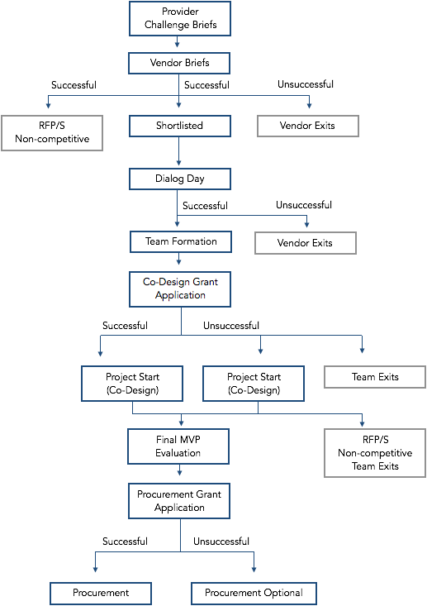

- Questions related to the Challenge being proposed must be directed to the Provider, and questions that modify the Challenge will be posted publicly for all potential proponents. Questions related to the Innovation Partnership: Procurement by Co-Design Program must be directed to MaRS (designchallenge@marsdd.com)
- Submission requirements (mandatory requirements; proponents who do not meet the mandatory requirements will be disqualified)
  - Interested proponents must respond via submission of an Innovator Brief document, available online on https://www.marsdd.com/systems-change/procurement-co-design
  - The Innovator Brief document must be submitted directly to the Provider by the due date listed on the cover page of this document, with a cc to designchallenge@marsdd.com.
  - The submission must include proof of necessary licenses.
- Bid disputes must be directed to the Provider, and will be managed according to the Provider’s published bid dispute resolution process.

