[Challenge Title]
Grant Application

Lead applicant (Ontario BPS healthcare provider)

Registered name of organization
Lead applicant contact name (project manager)
Full name of contact
Phone number |  | Challenge Brief reference #
Enter Phone# Here |  | Use the corresponding #
E-mail |  | Maximum procurement budget
Enter Email Address Here |  | $
 |  | Note: this does not obligate provider to procure any solution
Project role, full name, organization, title, email and phone number of each team member, including
- lead healthcare provider’s project manager and procurement officer
- lead vendor’s project manager
Project Team (lead healthcare provider, healthcare providers, vendors, stakeholders)

Project role, full name, title, organization, email and phone number of one or more executive champions (e.g. CEO, CIO, CTO, CFO, VP, Executive Director) from lead healthcare provider

Project role, full name, title, organization, email and phone number of one or more executive champions (e.g. CEO, CIO, CTO, CFO, VP, Executive Director) from lead vendor
Executive Champions (lead healthcare provider and vendor)
The Challenge
Maximum of 1200 characters
A good challenge statement is specific enough to offer a focused starting point yet broad enough to consider many ways to tackle it.

Too broad: “How to reduce falls in our senior care homes.”

Too specific: “We will reduce falls by 25% in the next year by creatively using wearable technology to monitor our residents during high-risk activities.”

More balanced: "How might we improve the quality of life of our residents by reducing falls in our senior care homes by 25% in the next year, by focusing on the top 3 causes (getting out of bed, entering and exiting the shower, sitting and standing)?"

Remember to address the following questions:
- How is this challenge important to the lead healthcare provider to deliver better care? How does this challenge align with strategic priorities?
- How does this challenge impact citizens, patients and/or caregivers; healthcare professionals, support workers and/or other stakeholders?
- What is the positive change that you believe could result from addressing the challenge?
- To what extent is this challenge shared by other healthcare provider organizations?

Innovation Partnership and Co-Design
Maximum of 2500 characters
Illustrate why this challenge needs innovation partnership and co-design
- What makes this challenge so complex, and challenging? Describe the complexities, interdependencies, constraints, and uncertainties – think about different dimensions.
- What are some ways that you and others have tried to solve this challenge? Why do these efforts fall short of solving this challenge?
- Why do current solutions in the market fall short of solving this challenge?
  - Demonstrate that you have taken reasonable efforts to investigate and conclude that there are no solutions available in the market that are feasible and viable for the lead healthcare provider.
  - If applicable, name examples of current solutions
- Why is innovation needed? Why is co-design needed?
  - Why are incremental improvements and changes inadequate?
  - Why are customizations of current market products inadequate?
- What gives you hope that you can solve this challenge? Despite efforts to date, and there being no feasible and viable solutions in the market.

The Approach
Maximum of 2500 characters
Please describe how the team plans to solve this challenge by telling us:
- What value will you create?
  - Who do you want to target as users or beneficiaries?
  - What experiences, and/or outcomes are you aiming to change?
  - What different experiences do you want to create?
- What or where would you focus on investigating and changing?
- How will you measure the success of the solution?
- What are your key assumptions and uncertainties?
- What opportunities can you leverage?
- What are the risks, how will you manage them?

Illustrate the practicality of the scope and approach, that you will be able to develop and test a minimal viable product within the time of this program.

Desired Outcomes
Maximum of 1200 characters
Describe the potential positive impact to the lead healthcare provider, e.g. quality of care, patient outcomes, family/caregiver outcomes, citizen health and wellness, healthcare practice, cost savings.

Describe the potential impact to Ontario’s healthcare system.

Illustrate why you believe the magnitude of change would be significant, not just incremental.

Maximum of 3 outcomes based specifications (OBS)
OBS specify the ultimate outcomes and performance desired by the end user, allowing for flexibility in determining how a specific need can be met. Here are some examples:

OBS #1: HospitalX is interested in reducing appointment no-shows from the current rate of 17% to less than 10% as measure over a 3-month period.

OBS #2: Increase patient satisfaction compared to the status quo. A baseline metric will be established during testing, and a minimum of 20% increase in patient satisfaction over the status quo is expected from the solution during a 3-month testing period.

OBS #3: Decrease clinical administrative load as measure by time saved and/or increased efficiency by a minimum of 20% over a 3-month test period.

Readiness
Maximum of 2000 characters
Who are the key decision makers (e.g. from your senior leadership team, from key partner organizations)? How have you engaged them? If you have not, how will you engage them?

Who are the key stakeholders (e.g. in your organizations, from key partner organizations)? How have you engaged them? If you have not, how will you engage them?

How will you involve your target end-users or beneficiaries in the co-design process?

What are the critical permissions and commitments required? Which ones have you secured? How will you secure the others? E.g.
- Commitment to allow the project manager and any additional staff participating in the co-design project the necessary resources to successfully follow the co-design process, including, work hours, work space.
- Access to target end-users and environments in appropriate and timely manner so that the project progresses according to the program timelines, e.g. physician testers, testing in the emergency department.

Tell us why procurement will be viable (if the solution meets agreed upon expectations)
- Reasonable commitment on at least one source of funds (other than this grant) towards procurement.
- If there is no funding available for procurement, what is the alternative? E.g. readiness of provider and vendor to enter into a partnership agreement.

Mandatory Requirements and Eligibility
- The lead applicant must be an Ontario Broader Public Service (BPS) organization.
- The proposed approach does not include technologies, procedures or components that require additional regulatory approval or accreditation.
- Contact details of lead healthcare provider includes project manager, procurement officer, and one or more executive champions (e.g. CEO, CIO, CTO, CFO, VP, Executive Director)
- Contact details of lead vendor includes project manager and one or more executive champions (e.g. CEO, CIO, CTO, CFO, VP, Executive Director)
- Applications must:
  - State at least one source of funding towards procurement of the solution, that procurement is feasible if the solution meets expectations
  - Show what applicants believe to be the potential positive impact on delivery of care and costs
  - Show why applicants believe the problem is solvable today; but there is nothing in the market that is feasible and viable. E.g. the problem can conceivably be solved by combining different offerings on the market, others are trying to solve it with varying degrees of success but none of these efforts are feasible and viable in Ontario.
- All questions in this grant application package must be answered, incomplete applications will be rejected.

Key Dates
The following is a summary of key dates in the RFP process. Program sponsor (MaRS) and provider may change any of the dates below, in its sole discretion and without liability, cost, or penalty.

Key Dates | Milestones | Duration
Sept 28, 2017 | Program launch, providers invited to download and complete a Challenge Brief | 2 weeks
Oct 16 - 20 | All challenges posted online, vendors begin to respond with Innovator Briefs | 1 week
Oct 23 - 27 | Vendors have all submitted Innovator Briefs. Providers shortlist vendor selection. | 1 week
Nov 6 | Dialog day. Each provider will hear their selected vendor pitches. Final vendor selection completed. | 1 day
Nov 7 - 10 | Teams prepare and submit co-design grant application. | 1 week
Nov 13 - 17 | External judging panel reviews grant applications. Meets on 17th to make final decision. Co-Design grant winners announced. | 1 week
Nov 20 | Co-Design Workshop #1: Discovery. Teams sign collaboration agreements. | 1/2 to 1 day
Nov 20 - Dec 15 | Teams work on discovery phase. | 4 weeks
Jan 15, 2018 | Co-Design Workshop #2: Ideation & Concept testing | 1/2 to 1 day
Jan 15 - Mar 3 | Teams work on ideation and concept testing phase. | 8 weeks
Mar 5 - 8 | Design review sessions. 1 - 2 hour sessions with each team to review learnings from discovery and concept testing results. | 1 week
Mar 9 | Co-Design Workshop #3: MVP prototyping and evaluation framework. | 1/2 - 1 day
Mar 9 - Jun 15 | Teams work on MVP development and evaluation phase. | 14 weeks
Jun 18 - Jul 5 | Teams make procurement decision and formalize agreements. | 3 weeks
Jul 9 - 13 | External judging panel conducts site visits. | 1 week
Jul 20 | Final solutions day. Judges award up to $50k for procurement. | 1 day

Terms and Conditions
- The “Innovation Partnership: Procurement by Co-Design” program may or may not lead to a procurement. There is no requirement for procurement at the end of the program, and procurement is at the discretion of the Provider. There are a number of potential outcomes from participation in this program (see figure below).
- This Design Challenge document is issued to invite vendors who are able to develop solutions within the program timelines or have existing solutions that require refinement or validation, to respond and partner with the Provider to solve the proposed challenge.
- The process will be in four phases:
  - Phase 1: Challenge Brief
    - Proponents prepare a submission in response to OBS
    - Providers evaluate submissions based on evaluation criteria published in Challenge Brief, and generate a short list of qualified proponents
  - Phase 2: Dialogue Day
    - Short listed proponents are invited to present on submissions
    - Providers evaluate presentation/discussion based on published criteria (to be made available to short listed proponents) and a proponent is selected. There are now two possible outcomes:
      - Proponent may find an ideal solution and decide to pursue an RFP/S or non-competitive procurement strategy
      - Proponent may form a team to pursue co-design
  - Phase 3: Co-Design
    - Selected proponent and provider form a team to co-design a solution and evaluate a minimum viable product, and decide whether to apply for the co-design grant. There are now three possible outcomes:
      - Co-design moves forward with grant funding
      - Co-design moves forward without grant funding
      - Co-design does not move forward
  - Phase 4: Procurement
    - Providers evaluate success of the minimum viable product based on published desired outcomes
    - Providers determine whether to move forward with a procurement, and whether to request the additional grant from IPPCD. There are now three possible outcomes:
      - Procurement moves forward with grant funding
      - Procurement moves forward without grant funding
      - Procurement does not move forward

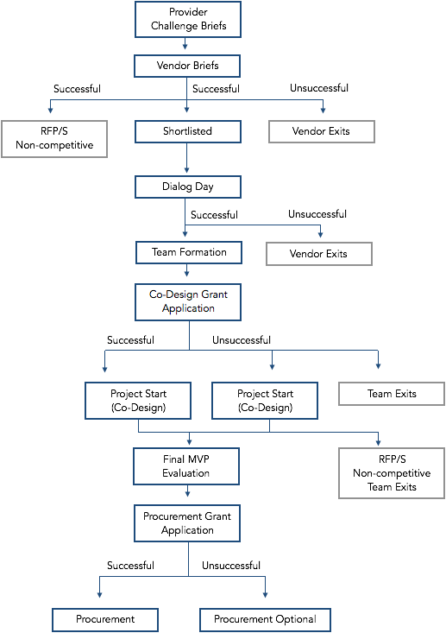

- Questions related to the Challenge being proposed must be directed to the Provider, and questions that modify the Challenge will be posted publicly for all potential proponents. Questions related to the Innovation Partnership: Procurement by Co-Design Program must be directed to MaRS (designchallenge@marsdd.com)
- Submission requirements (mandatory requirements; proponents who do not meet the mandatory requirements will be disqualified)
  - Interested proponents must respond via submission of an Innovator Brief document, available online on https://www.marsdd.com/systems-change/procurement-co-design
  - The Innovator Brief document must be submitted directly to the Provider by the due date listed on the cover page of this document, with a cc to designchallenge@marsdd.com.
  - The submission must include proof of necessary licenses.
- Bid disputes must be directed to the Provider, and will be managed according to the Provider’s published bid dispute resolution process.

