Exercise #1: Understanding Your Customer(s)
We get so caught up in the product that we often forget who it’s for and how it fits into their lives. We also tend to focus purely on functionality, but product functionality is just table stakes. It’s not what sells.

What sells is trust. Trust begins with your customer really feeling like you “get” them. And to get them, you need to get up close and personal, and listen to what they have to say, not just about your product but about the larger context of their lives. You need to empathize.

For this exercise, you will become an amateur ethnographer. All that means is that you are going to have a conversation with one or more of your potential customers. Your objective is simple: to listen.

Sounds obvious, doesn’t it? Most of us are really bad at it. But it is a core ethnographic skill, and when done right, it uncovers unmet and unarticulated needs that don’t give themselves up too easily. And these needs become fuel for product development and brand making.

Step 1: Identify a Potential Customer If you are B2B, you actually have two customers: the business buyer and the end-user. For this exercise, let’s focus on the business buyer. For example, if your product is for use in the healthcare space, isolate who the buyer might be. Is it a procurement executive in a large healthcare organization? Is it a doctor? Some other kind of HCP? All three?

Step 2: Formulate Questions Your second task is to come up with a list of questions for your buyer. If the list were in chart form, it might look like this:

Step 3: Conduct Interviews Set aside at least an hour for each interview. It is absolutely necessary to do this face to face so you can pay attention to the nuances of body language, observe the emotional state of the interview subject and listen for subtext. Be sure to record the conversation. Video is ideal, but audio will suffice, if necessary.

Step 4: Repeat Ideally, you want to conduct 10 to 12 of these in-depth interviews, depending on the variety of players affected. In a healthcare scenario, for example, you want to speak to buyers, HCPs and patients to get a robust 360-degree view of the situation. You will need to adapt the questions slightly to suit the interviewee. If you are not entirely comfortable or lack the time to conduct all 10 to 12 interviews, seek the aid of an ethnographer.

Step 5: Report Chart your findings in whatever format is most useful.

Tools Required:
• Questionnaire
• Audio or video recorder
• MS Word, Excel
Time Required: one hour per interview; two hours per interview for documentation

Exercise #2: Understanding Your Company
This is really about how you play to win. And we are going to use one of the other frameworks mentioned above to help you do that: Treacy and Wiersema’s Value Disciplines.

The beauty of this framework is that at the highest level, it makes your choices very easy. It contends that you have three choices:
• Operational efficiency
• Product leadership
• Customer intimacy

Most companies go to market with some combination of all three. It is better to choose two and lead with one. You can’t possibly do all three well, and even if you pick just two, one of those needs to be the priority.

In this exercise, you will need to look at your enterprise through each lens and ask yourself which one you are best suited—as a company and a culture—to prioritize. Let’s look at each option in more detail:

Operational efficiency: focus on reducing costs so you can compete on price
Product leadership: focus on product innovation and speed to market
Customer intimacy: focus on customer relationships and unparalleled service

It is critical that you respond honestly to this question, because your answer will be a significant driver of your brand strategy. It forces you to make trade-offs.

For example, if operational efficiency is your focus, you will not be able to spend as much time or money on the other two options, because cost-cutting takes precedence. You will still need to meet parity with product and customer service, but cost will be the most important driver of your success (think Dell).

If product leadership is your focus, you’ll need to invest the major part of your time and money on product innovation. Customer service and operational efficiency will be less of a priority (think Apple).

If customer intimacy is your focus, you will invest most of your time and money in getting to know your customer so well that you can anticipate their needs and have mechanisms in place to deal with them (think Zappos).

Which one you choose will guide how you are positioned against your competitors.

You can accomplish the above in a two- to three-hour internal workshop. Be sure to invite team members from different functional areas to get multiple perspectives and a balanced dialogue.
If you are having difficulty sorting through the options, you can also build yourself a simple SWOT grid and use that to guide your thinking. Do a SWOT analysis for each option.

Tools Required:
• Easels and large pads for note taking and “thinking out loud”
• Value Disciplines chart, printed or drawn on large sheets
• SWOT charts, printed or drawn on large sheets
Time Required: three hours for workshop; one to two hours for documentation

Exercise #3: Understanding Your Competition
You can’t position your enterprise, product or service without understanding what you are up against in the marketplace.

This exercise can be as deep as you want it to be. Ideally, it is an exercise that will need to be revisited as marketplace dynamics change. You can start at a very basic level for positioning purposes, and you will always be able to enrich your analysis with greater and greater detail as time goes by.

Step 1: Create a Positioning Grid

Depending on how industrious you feel, you could also put together a SWOT for each competitor.

Step 2: High-Level Cluster Mapping
The idea here is to cluster competitors according to one of the three Value Disciplines. A simple Venn diagram in which each of three overlapping circles represents one of the Value Disciplines allows you to visualize the information you have charted in Step 1. It would look like this:

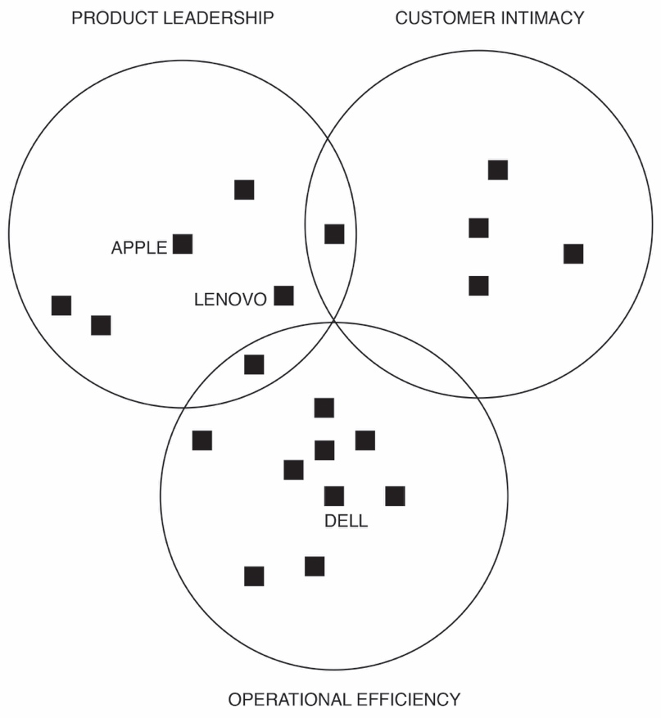

Each black square represents one of the companies you are competing with. Using the companies in the chart in Step 1, you would place Apple in the dead centre of Product Leadership and Dell in the centre of Operational Efficiency, and Lenovo would sit somewhere between Product Leadership and Operational Efficiency. If a company claims to deliver two out of the three Value Disciplines, it would sit where the circles overlap.

This is a fairly subjective placement and very high-level, but it is a useful way to create a quick picture of where you should play in order to occupy a position that is currently absent of worthy competitors.

You will refer to all of these tools as you work your way through the formulation of your brand strategy.

Tools Required:
• Sticky notes
• Positioning grid (Excel)
• Easels and large pads for note taking and “thinking out loud”
• Wall for initial clustering of sticky notes
Time Required: three hours for each exercise; one to two hours for documentation

