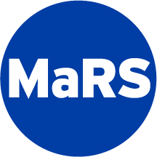

Innovation Partnership: Procurement by Co-Design Toolkit

Challenge Brief Template

[Purchaser Name: Challenge Title]

Challenge Brief

Purchaser Contact name |  | Response deadline
Enter Full Name Here |  | Enter Date Here
Phone number |  | Challenge Brief reference #
Enter Phone # Here |  | Enter A Unique Number
E-mail |  | Maximum procurement budget
Enter Email Address Here |  | $ Enter the max procurement amount
 |  | Note: this does not obligate purchaser to procure any solution
Enter Full Name, Role
Purchaser Project Team
All supplier responses must be made via completion of a “Supplier Brief” template and forwarded to the above contact via email by the response deadline, with a cc to x@x.com.

The Challenge
Maximum of 1200 characters.
Enter a description of the challenge you wish to address via the innovation partnership, procurement by co-design.
Note: A good challenge statement is specific enough to offer a focused starting point yet broad enough to consider many ways to tackle it.
Too broad: “How to reduce falls in our senior care homes.”
Too specific: “We will reduce falls by 25% in the next year by creatively using wearable technology to monitor our residents during high-risk activities.”
More balanced: "How might we improve the quality of life of our residents by reducing falls in our senior care homes by 25% in the next year, by focusing on the top 3 causes (getting out of bed, entering and exiting the shower, sitting and standing)?"
Remember to address the following questions:
- How is this challenge important to the organization to deliver better care?
- How is this a challenge also faced by other organizations?
- What are some ways that you have tried to solve this challenge in the past?
- Why do current solutions in the market fall short of solving this challenge?

Desired Outcomes
OBS specify the ultimate outcomes and performance desired by the end user, allowing for flexibility in determining how a specific need can be met. Here are some examples:
OBS #1: Hospital X is interested in reducing appointment no-shows from the current rate of 17% to less than 10% as measure over a 3-month period.
OBS #2: Increase patient satisfaction compared to the status quo. A baseline metric will be established during testing, and a minimum of 20% increase in patient satisfaction over the status quo is expected from the solution during a 3-month testing period.
OBS #3: Decrease clinical administrative load as measure by time saved and/or increased efficiency by a minimum of 20% over a 3-month test period.

Evaluation Criteria
Criteria to be used for supplier selection (NOT to evaluate solutions).
Describe how the purchaser will evaluate suppliers. Below are evaluation categories for purchaser use. Please modify according to your needs by adding any criteria or sub-criteria and weights if necessary.

Company
Has the company demonstrated the competency to act as partner? Do they have an innovative vision? Do they have a strong leadership team? Do they have strong references?

Proposed approach
Is the proposed approach to the challenge innovative? Do you agree that it can solve the challenge proposed? Will it have a significant impact on the end user (staff, patients, etc)?

Ability to execute
Has the company demonstrated the ability to deliver a solution to other complex challenges? What has been the outcomes of solutions they have implemented?

Ability to produce validation data
Has the company demonstrated their ability and expertise to produce validation data? Have they shared an example of data they have produced for any of their products or prototypes? Is the quality of that data sufficient enough to make a procurement decision?

Experience of project team
Does the team have experience working on innovative solutions? Did the company propose the right type of project team to take on this engagement?

Key Dates
The following is a summary of key dates and milestones for this Innovation Partnership, Procurement by Co-Design project.
Modify the table below according to your procurement process.
Key Dates | Milestones | Duration
Oct 23 - 27 | Suppliers have all submitted Supplier Briefs. Purchaser shortlist supplier selection. | 1 week
Nov 6 | Dialog day. The purchaser will hear their selected supplier pitches. Final supplier selection completed. | 1 day
Nov 20 | Co-Design Workshop #1: Discovery. Teams sign collaboration agreement and complete site visit. | 1/2 to 1 day
Nov 20 - Dec 15 | Team work on discovery phase. | 4 weeks
Jan 15, 2018 | Co-Design Workshop #2: Ideation & Concept testing | 1/2 to 1 day
Jan 15 - Mar 3 | Team work on ideation and concept testing phase. | 8 weeks
Mar 5 - 8 | Design review sessions. 1 - 2 hour sessions with each team to review learnings from discovery and concept testing results. | 1 week
Mar 9 | Co-Design Workshop #3: MVP prototyping and evaluation framework. | 1/2 - 1 day
Mar 9 - Jun 15 | Teams work on MVP development and evaluation phase. | 14 weeks
Jun 18 - Jul 5 | Teams make procurement decision and formalize agreements. | 3 weeks

Terms and Conditions
Modify this section below according to your procurement process.
- The “Innovation Partnership: Procurement by Co-Design” project may or may not lead to a procurement. There is no requirement for procurement at the end of the project, and procurement is at the discretion of the purchaser. There are a number of potential outcomes from participation in this program (see figure below).
- This Challenge Brief document is issued to invite suppliers who are able to develop solutions within the project timelines or have existing solutions that require refinement or validation, to respond and partner with the purchaser to solve the proposed challenge.
- The process will be in four phases:
- Phase 1: Challenge Brief
- Proponents prepare a submission in response to OBS
- Purchasers evaluate submissions based on evaluation criteria published in Challenge Brief, and generate a short list of qualified proponents
- Phase 2: Dialogue Day
- Shortlisted proponents are invited to present on submissions
- Purchasers evaluate presentation/discussion based on published criteria (to be made available to short listed proponents) and a proponent is selected. There are now two possible outcomes:
- Proponent may find an ideal solution and decide to pursue an RFP/S or non-competitive procurement strategy
- Proponent may form a team to pursue co-design
- Phase 3: Co-Design
- Selected proponent and purchaser form a team to co-design a solution and evaluate a minimum viable prototype.

- Phase 4: Procurement
- Purchaser evaluate success of the minimum viable product based on published desired outcomes
- Purchasers determine whether to move forward with a procurement
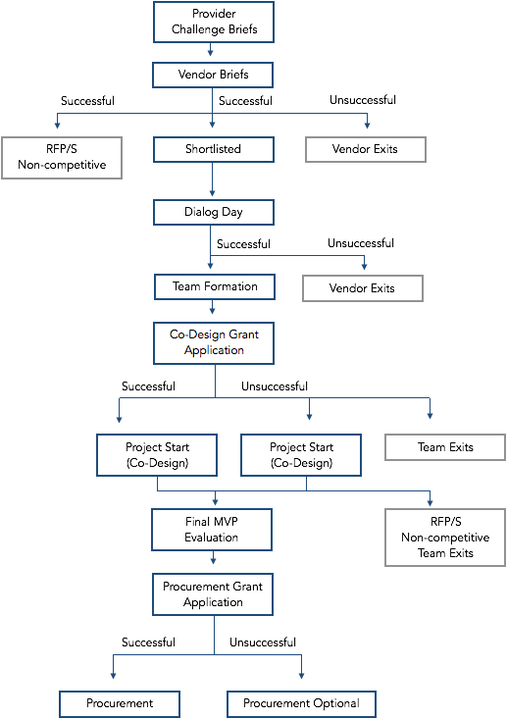

- Questions related to the Challenge Brief being proposed must be directed to the purchaser and questions that modify the Challenge Brief will be posted publicly for all potential proponents.
- Submission requirements (mandatory requirements; proponents who do not meet the mandatory requirements will be disqualified)
- Interested proponents must respond via submission of an Supplier Brief document, available online on : xxx
- The Supplier Brief document must be submitted directly to the purchaser by the due date listed on the cover page of this document xx.
- The submission must include proof of necessary licenses.
- Bid disputes must be directed to the purchaser, and will be managed according to the purchaser’s published bid dispute resolution process.

