Innovation Partnership: Procurement by Co-Design Toolkit

Concept & Field Prototyping Guide
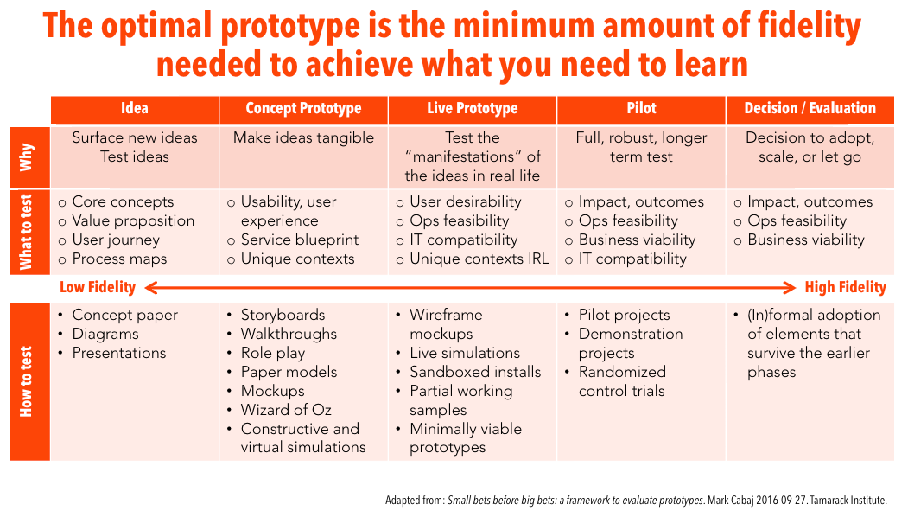
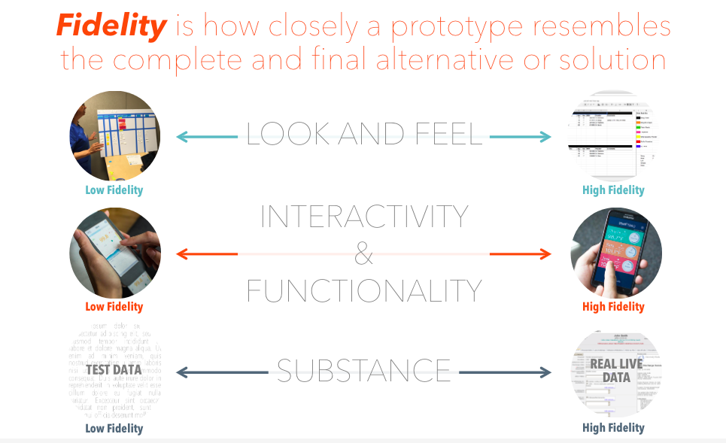
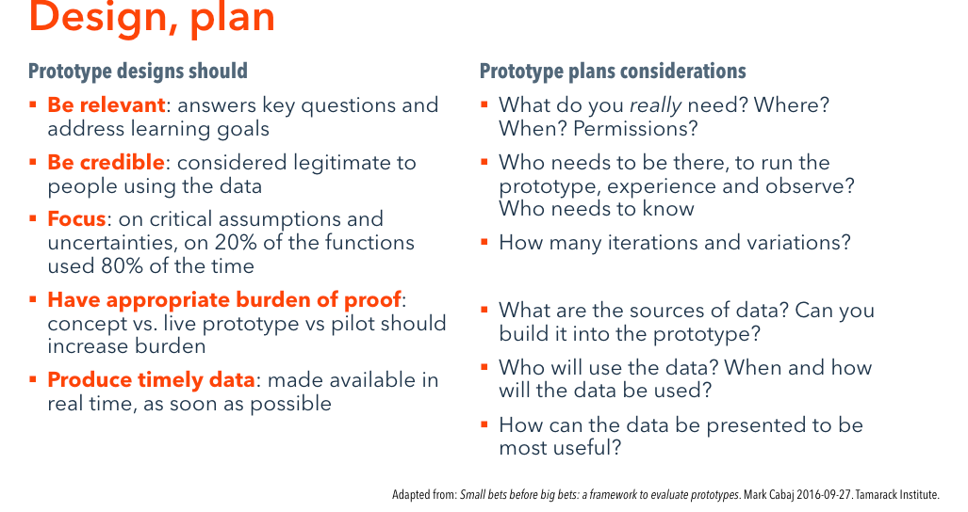
Journal entry by <Journaler>, <Date>

1.1.1. Your Concept Prototyping Plan
Your solution will have elements that require rapid testing. What is your prototyping plan to rapidly test those elements? What are some questions you need answered about your solution before you develop a minimum viable product to evaluate? What methods will you use for prototyping? How will you test the concepts? After prototyping and testing, what have you learned? Summarize any insights you gained. Summarize any assumptions that were challenged.

