Innovation Partnership: Procurement by Co-Design Toolkit

Ecosystem Map Exercise

Materials
Whiteboard or chart paper, markers, sticky notes

Goals
- Begin to unpack the who/what/where/how/why of the challenge that they are addressing through IPPCD
- Gain an understanding of the "bigger picture", so that you have a better understanding of all the connections between stakeholder and organizations as well as activities that happen.

Instructions
- Working as a team, create an ecosystem quadrant like the one below on a large sheet of paper or whiteboard.
- For completing the quadrant, each team member takes a couple of minutes to fill a quadrant with 3 - 5 items using the sticky notes. Everyone shares back to the team and the rest of the team adds any other items they can think of for each quadrant.
Ecosystem Quadrant
People & Networks  Who might this challenge and project affect?  Who might we talk to? | News, Tech, Trends  What trends might we take advantage of to solve this challenge?
Activities & Touchpoints  What kinds of activities and processes might be relationed to this challenge and project? | Places & Spaces  What are some important places we need to consider?
- Review your challenge canvas and ecosystem quadrant
- Create a drawing that shows the overall system view of the challenge
- Pick a starting point and a stakeholder - where does their problem begin?
- Show how one thing has led to another - what happens to that stakeholder and where?
- Pick another stakeholder - how do they fit into the picture?
When you are done, your Ecosystem Map might look like this:
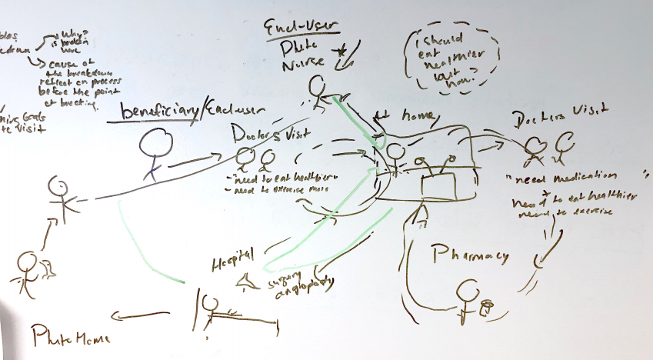
- Now looking at your Ecosystem Map, is there any process or any stakeholder you are missing?

