Innovation Partnership: Procurement by Co-Design Toolkit

Storyboard & Animatic Prototype Exercise

From Storyboard to Video
We all know that a picture is worth a thousand words but a prototype is worth a thousand meetings. Storyboards are a way to visually plot out elements of your idea, while videos can help you get further clarity on a critical touchpoint or multiple touchpoints of your idea. Both help you refine what your idea is and uncover who will use it, where and how.
Remember, you don’t have to be a great artist or cinematographer, keep things rough as you think your idea through.

Materials
Storyboard cards, paper, sticky notes, pen, pencils, markers, cardboard or poster board, glue or tape, camera or smartphone.
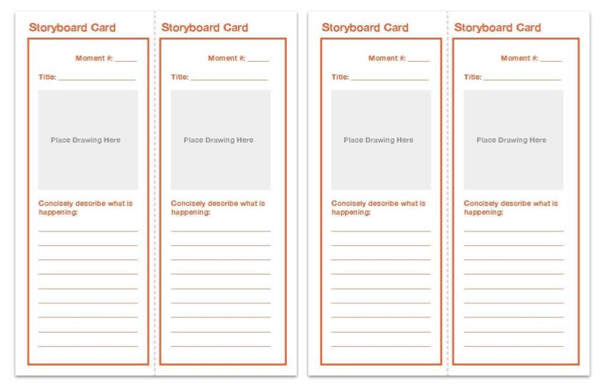 | 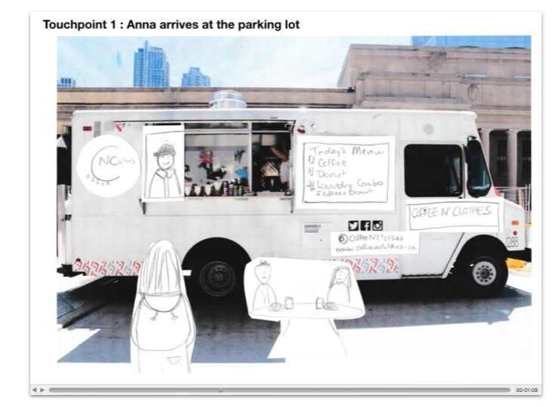

Suggested Time
60 minutes each

Examples
Coffee N’ Clothes Storyboard
Coffee N’ Clothes Video

Steps: Storyboard
01 | Define your story.  What part(s) of your idea do you want to storyboard? Maybe it’s an important interaction or feature of your idea. Or maybe you just want to visualize the experience from beginning to end.
02 | Pick your characters.  Who is the main character? This might be the person who will directly benefit from your idea or it might be the person who will be offering a new service. Define your supporting characters. Name them and give them some characteristics like age and gender.
03 | And then the plot thickens!  Outline your story using bullets plots. Keep it simple, but make sure like all good stories it has a beginning, middle and end. Think about things like where your story begins, how your characters first meet, how do the characters win or get what they want/need?
04 | Sketch out the key moments.  Use a separate storyboard card for each key moment, sketch out each frame on a sticky note. Make sure to include the people involved, where they are and what they are doing, saying, or thinking. Add your sticky note to the card and write a short description below of what is happening.  If you need to make any revisions, don’t throw out the old sticky note, just put the new drawing on top (and try not to worry too much about the quality of your drawings).
05 | Review, Rearrange, Run-Through.  Once you’ve completed sketching your key moments, run through your story in sequence, edit and reorder if necessary. Make sure that all of your characters are represented and that your storyboard shows how your main character wins.  Once you’ve got your final cut, share your storyboard with different people including any important stakeholders who can help bring your idea to life. Make note of their feedback and make changes on the fly. Keep testing until you think you’ve gotten enough insights.

Steps: Video
01 | Define your touch points.  When you are planning to test out an idea, one way to help break a big idea down is to think about the touchpoints. Touchpoints are when someone interacts with your idea. These touchpoints will vary depending on the solution you are testing. They could be people to people interactions like at a service desk, people to digital tools interactions like using a website, a phone call, or a smartphone application, or people to analog tools interactions like filling out an application form or reviewing a booklet.  Decide what touchpoint(s) of your idea you will include in your video by thinking about what uncertainties you have about your idea. Maybe you want to understand how someone might sign up for a service using a website or bulletin board. Maybe you have questions around how multiple people will complete a task together.
02 | Draft your Storyboard and Script.  Start by drawing 2 - 3 “shots” that detail what happens during the touchpoint you selected. Think about incorporating different types of frames to help tell your story:  - Establishing frame to show where your character(s) are and who they are  - Medium frame to show what’s happening  - Close-up of what the character is seeing or doing  Beside each image, write out the matching voice-over narration. (This is not a description of what’s happening in the image, but complements the image to convey the story and key messages).
03 | Lights, Camera, Action.  Once you have confirmed your draft shot sequence and script, line up all the “shots” into a vertical strip for the shoot.  A simple way to record the video is to have one person video using their phone (or video camera if you have one) by panning from image to image while another team member narrates the voice-over.  You can also record your video by using photographs to increase the level of detail in your video. You might be able to find some existing photos that you can mark up or draw over, or you can stage your own photos.  Review the video and make any necessary changes.
04 | Test with an audience.  Like any great film you’ll want to test your video with the target audience and get some feedback.  Write out a list of questions that you want to ask stakeholders. Some examples:  - Would you use something like this?  - Would you change anything?  - Would you take out or add any touchpoints?  - Was any part confusing?  - What did you like? What did you not like?  Record any feedback.

