Innovation Partnership: Procurement by Co-Design Toolkit

Team Charter Exercise

Suggested Time
20-30 minutes.

Difficulty
Easy.

Materials
Pens, paper, whiteboard, markers.

Participants
All project team members.

Tips
Try to add some humor with the rules.
Refer back to the team charter as needed throughout the design process.
Each person has their own unique skillset and preferences for how they like to work. Establishing clear codes of conduct, and defining roles and responsibilities upfront before a project begins, will keep the team aligned throughout the design journey.

Steps
- Describe your team objective. Write down in no more than 2 sentences what the team wants to accomplish. Align yourselves around a common purpose.
- Identify the core team. Write down who are the team members from both the provider and vendor sides who are prepared to commit a meaningful amount of their time to the project (i.e. who will be doing the heavy lifting).
- Identify the part time team. Write down those who bring expertise at a particular point of the process.
- Identify your advisors. Those who will be brought in on a regular and focused basis.
- Discuss roles and responsibilities.
- List and discuss meeting and communication strategies. When and where are you planning to have check-ins? What is the best way to ask questions of the group? What resources or tools will you use to schedule meetings and share and store information?
- Come up with team rules and codes of conduct. Put out all your pet peeves on the table early on.

What might this look like?
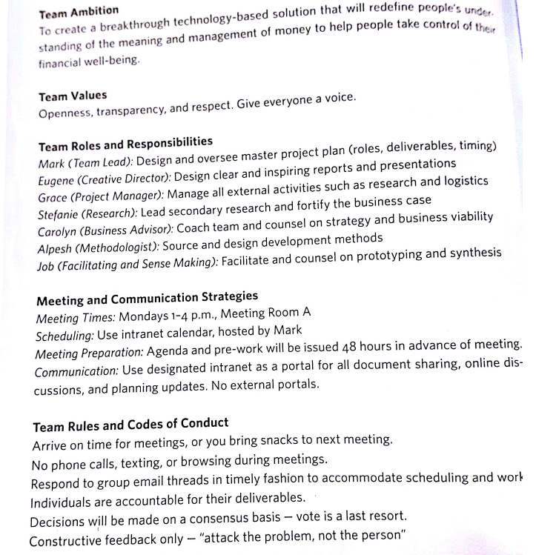

Key References
Heather M.A Fraser. Design Works, How to Tackle Your Toughest Innovation Challenges Through Business. Canada. University of Toronto Press. 2012.

